**AS 3959 cases**

Comparison of radiative heat flux of AS 3959 method and simulaton.

The radiative heat flux was calculated according to the given method in AS 3959 standard.

During the calculation procedure following parameters were assumed.

* Ambient temperature ($T_{a}$) =308 K (35 0C)
* Relative humidity (RH) = 25%
* Flame emissivity ($ε$) = 0.95
* Flame temperature ($T_{f}$) =1090 K

Basic equations:

1. The radiant heat flux (kW/m2)
2. Flame emissive power

$$E=σεT_{f}^{4}$$

We consider only the flat land (vegetation and site at the same tevel). So $θ=0$ in the caclculation and flame center is over the ground level.

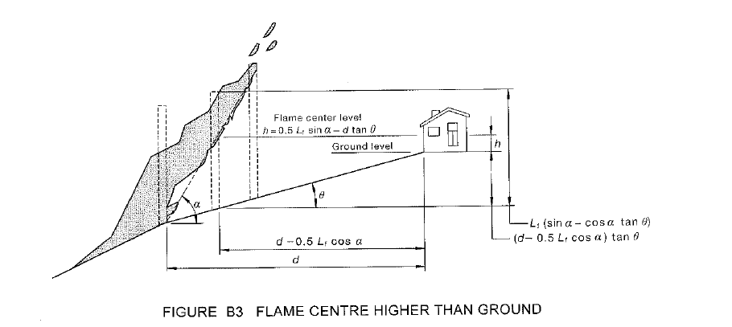



Radiative heat flux at different heat angles (Forest FDI100)

|  |
| --- |
|  |